Pizza Sales Sql Queries

* **For KPI’s Requirements**

1. **Total Revenue:**

select SUM(total_price) as TOTAL_Revenue from pizza_sales

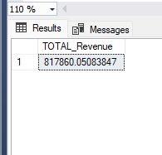

1. **Average Order Value:**

SELECT SUM(total_price)/COUNT(distinct order_id) as AvgOrderValue from pizza_sales

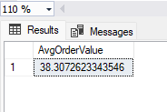

1. **Total pizza sold**

select SUM(quantity) as Total_pizza_sold from pizza_sales

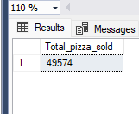

1. **--Total orders**

select count (distinct order_id) as total_orders from pizza_sales

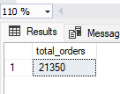

1. **--Average Pizza per order**

select SUM(quantity)/count(distinct order_id) as AvgPizzaPerOrder from pizza_sales

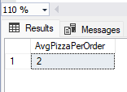

**If you want in decimal**

select cast(sum(quantity) as decimal(10,2))/

cast(count(distinct order_id)as decimal(10,2)) as AvgPizzaPerOrder

from pizza_sales

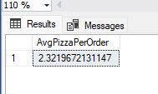

**If you want in decimal or only 2 decimal place**

select cast(cast(sum(quantity) as decimal(10,2))/

cast(count(distinct order_id)as decimal(10,2) )

as decimal(10,2)) as AvgPizzaPerOrder from pizza_sales

* **For Charts Requirements**

1. **Daily Trends for Total orders**

select datename(DW,order_date) as order_day,count(distinct order_id)

as DailyTrendforTotOrder from pizza_sales

group by datename(DW,order_date)

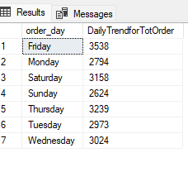

1. **Monthly Trends for Total orders**

select DATENAME(MONTH,order_date) as Months,count(distinct order_id)

as monthlyTrendforTotOrder from pizza_sales

group by DATENAME(MONTH,order_date) order by count(distinct order_id) desc 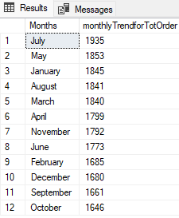

1. **Hourly Trends for Total orders**

SELECT datepart(HOUR ,order_time) AS hour,

COUNT(distinct order_id) AS total_orders

FROM pizza_sales GROUP BY hour

ORDER BY hour desc;

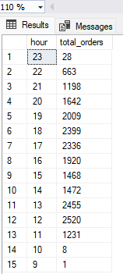

1. **Percentage of sales by pizza category**

select pizza_category, sum(total_price)*100 / (

select sum(total_price) from pizza_sales)

as perofsales from pizza_sales group by pizza_category

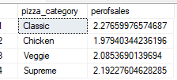

1. **Percentage of sales by pizza size**

select pizza_size,sum(total_price) as Totalsales,cast(sum(total_price) *100 /

( select sum(total_price)from pizza_sales) as decimal(10,2))

as Per_of_sales_by_pizza_size

from pizza_sales group by pizza_size

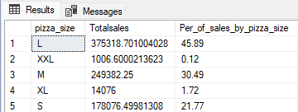

1. **Top 5 sellers by revenue, total quantity and total orders**

select Top 5 pizza_name,

sum(total_price) as total_revenue,

sum(quantity) as total_quantity,

count(distinct order_id) as totalorders

from pizza_sales group by pizza_name

order by total_revenue desc,

total_quantity desc,

totalorders desc

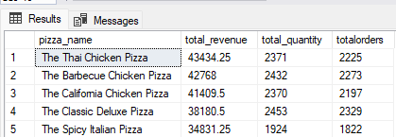

1. **Bottom 5 sellers by revenue, total quantity and total orders**

select Top 5 pizza_name,

sum(total_price) as total_revenue,

sum(quantity) as total_quantity,

count(distinct order_id) as totalorders

from pizza_sales group by pizza_name

order by total_revenue ,

total_quantity ,

totalorders

